700 runners in 6th Annual Grade School Cross Country race

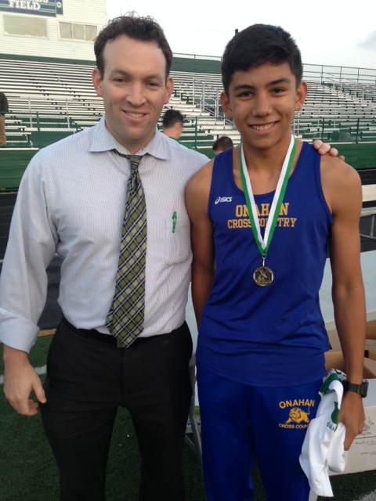
Notre Dame College Prep Vice President for Advancement and Enrollment Shay Boyle (left) congratulated Jack Burns from Onahan School (right) who won the 7th/8th Grade Boys Varsity race.
[October 8, 2015 - Niles, IL] Over 40 teams and 700 runners participated in Notre Dame College Prep’s 6th Annual Grade School Cross Country race on October 7, 2015. Held on the campus of NDCP in Niles, Illinois, four races were held including one mile runs for 5th/6th grade girls and 5th/6th grade boys and one and one half mile runs for 7th/8th grade girls and 7th/8th grade boys. The race was sponsored by NDCP’s Cross Country Team and the Enrollment Department.
"This annual race provides a tremendous opportunity for young athletes to experience great competition with other grade school teams. Each year we are impressed by the quality of running and the sportsmanship that is exhibited by the athletes," said Notre Dame College Prep's Head Cross Country Coach John Barrett. He is also a Class of 2007 alumnus.
"We're glad to have such a beautiful and large campus to hold this free event. It's wonderful to see so many runners participating in the race and to have their families here cheering them on. We look forward to seeing everyone back next year," added NDCP's Vice President for Advancement and Enrollment Shay Boyle.
The top 25 individual racers in each race received a medals and an NDCP Cross Country t-shirts. The top three teams in each division received trophies. The results for the races are below.

Varsity Boys (7th/8th Grade - 1.5 mile) - Top 25 Individuals:
NAME |  |  | SCHOOL |  |  | TIME
Jack Burns |  |  | Onahan |  |  | 8:34
Patric Natindim |  |  | St. Emily |  |  | 8:35
Eric Stemper |  |  | Queen of Angels |  |  | 9:01
Alex Tan |  |  | St. Andrew |  |  | 9:03
Alex Owens |  |  | Pope John XXIII |  |  | 9:05
Charlie Clary |  |  | St. Athanasius |  |  | 9:13
Matt Czech |  |  | Queen of Angels |  |  | 9:14
Everett Andrew |  |  | St. Francis Xavier |  |  | 9:16
Evan Bajerski |  |  | St. Francis de Sales |  |  | 9:16
Matthew Cull |  |  | Mary, Seat of Wisdom |  |  | 9:20
Danny Riordan |  |  | St. Andrew Lutheran |  |  | 9:22
Tommy Cortese |  |  | St. Emily |  |  | 9:26
Elliot Myers |  |  | CICS |  |  | 9:27
Cristian DeLaCruz |  |  | Queen of Angels |  |  | 9:28
Conner Dalton |  |  | St. Andrew |  |  | 9:30
Nathan Rochera |  |  | Our Lady of the Wayside |  |  | 9:31
Scott Rogowski |  |  | St. Emily |  |  | 9:31
Sam Celli |  |  | Garvy |  |  | 9:33
Will Czech |  |  | Queen of Angels |  |  | 9:33
Julian Valtierrez |  |  | Smyser |  |  | 9:34
Alex Miller |  |  | St. Francis de Sales |  |  | 9:35
Luke Musseur |  |  | Queen of Angels |  |  | 9:35
Sal Gumina |  |  | Queen of All Saints |  |  | 9:39
Baito Sarkiss |  |  | Brickton Montessori |  |  | 9:43
Lucas Geiger |  |  | St. Emily |  |  | 9:47
Varsity Boys (7th/8th Grade - 1.5 mile) - Top 12 Teams
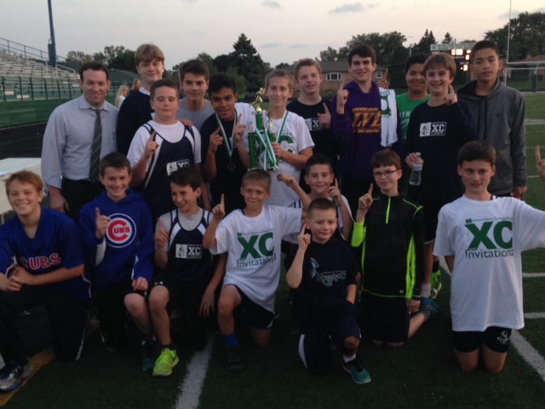 |  | 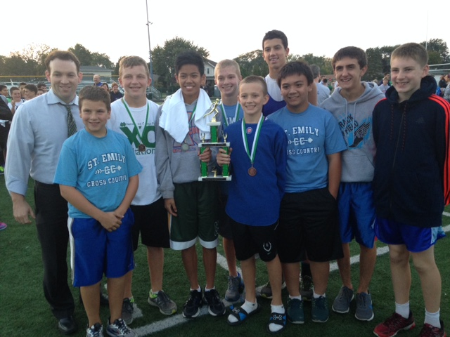 |  | 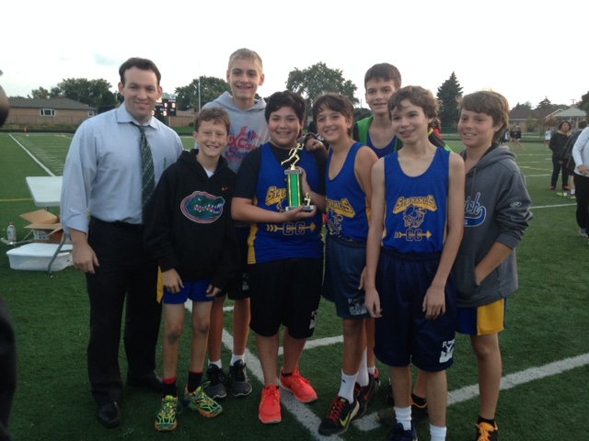
1st Place Varsity Boys  Queen of Angels |  | 2nd Place Varsity Boys  St. Emily |  | 3rd Place Varsity Boys  St. Francis de Sales

SCHOOL |  |  | SCORE (POINT TOTAL)
Queen of Angels |  |  | 65
St. Emily |  |  | 90
St. Francis de Sales |  |  | 155
St. Athanasius |  |  | 181
Garvy |  |  | 202
St. Andrew |  |  | 207
CICS |  |  | 262
Our Lady of the Wayside |  |  | 286
Smyser |  |  | 334
St. Francis Xavier |  |  | 348
Belding |  |  | 394
Palmer |  |  | 469

Varsity Girls (7th/8th Grade - 1.5 mile) - Top 25 Individuals
NAME |  |  | SCHOOL |  |  | TIME
Kristina Dalton |  |  | St. Andrew |  |  | 9:39
Joy Bergstrom |  |  | St. Emily |  |  | 9:53
Aubrey Hasley |  |  | St. Emily |  |  | 9:55
Lizzie Quakenbush |  |  | St. Athanasius |  |  | 10:00
Alex Guzzardo |  |  | St. Andrew |  |  | 10:05
Nicole Cleland |  |  | St. Andrew |  |  | 10:06
Regan Cooney |  |  | St. Andrew |  |  | 10:06
Ella Richards |  |  | Queen of Angels |  |  | 10:08
Mia Trotter |  |  | St. Andrew |  |  | 10:09
Eleanor Ward |  |  | St. Athanasius |  |  | 10:15
Megan Berti |  |  | St. Juliana |  |  | 10:19
Annie Gaughan |  |  | Mary, Seat of Wisdom |  |  | 10:23
Lucia Roth |  |  | St. Andrew |  |  | 10:25
Laiken Lockley |  |  | Our Lady of the Wayside |  |  | 10:27
Audrey McGrath |  |  | St. Francis de Sales |  |  | 10:30
Charleen Neco |  |  | Disney II |  |  | 10:32
Gabriella Plagari |  |  | St. Emily |  |  | 10:33
Emma Young |  |  | CICS |  |  | 10:34
Luna Johnston |  |  | Peterson |  |  | 10:35
Mallory Machala |  |  | St. Francis de Sales |  |  | 10:36
Mary Barr |  |  | Queen of All Saints |  |  | 10:36
Grace Couture |  |  | Queen of All Saints |  |  | 10:37
Gwen Casey |  |  | Peterson |  |  | 10:38
Reese Giodarino |  |  | Queen of Angels |  |  | 10:38
Sarah Jay |  |  | Edgebrook |  |  | 10:39

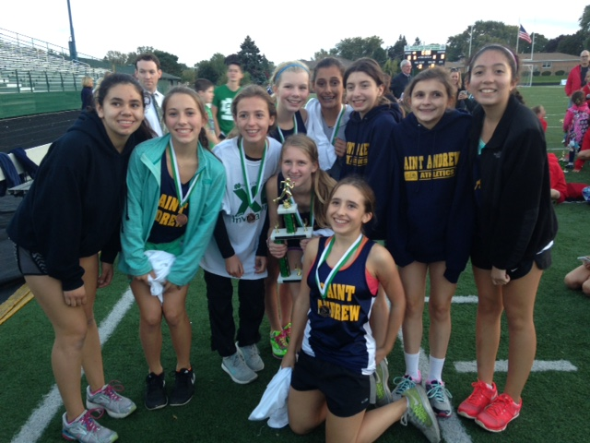 |  | 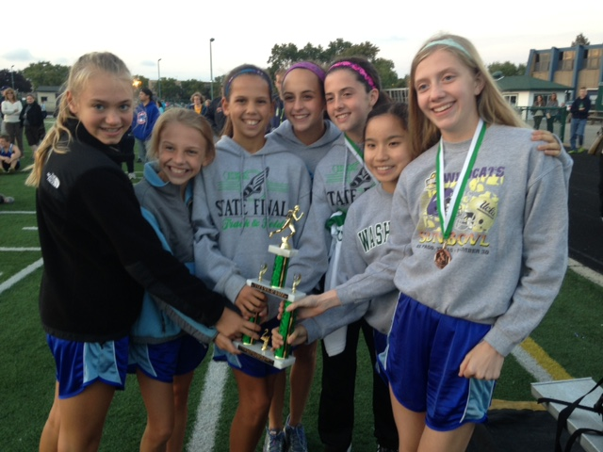
1st Place Varsity Girls  St. Andrew |  | 2nd Place Varsity Girls  St. Emily |  | 3rd Place Varsity Girls  St. Athanasius (photo not available)

Varsity Girls (7th/8th Grade - 1.5 mile) - Top 14 Teams
SCHOOL |  |  | SCORE (POINT TOTAL)
St. Andrew |  |  | 28
St. Emily |  |  | 97
St. Athanasius |  |  | 151
St. Francis de Sales |  |  | 171
Queen of Angels |  |  | 215
Disney II |  |  | 217
St. Luke |  |  | 223
Mary, Seat of Wisdom |  |  | 254
Queen of All Saints |  |  | 258
CICS |  |  | 295
Peterson |  |  | 383
St. Juliana |  |  | 425
Palmer |  |  | 463
Smyser |  |  | 512

Junior Varsity Boys (7th/8th Grade - 1 miles) - Top 25 Individuals
NAME |  |  | SCHOOL |  |  | TIME
Ryan Schaefer |  |  | Queen of All Saints |  |  | 6:10
Lachlan Andrew |  |  | St. Francis Xavier |  |  | 6:11
Rowan McDonnell |  |  | Our Lady of the Wayside |  |  | 6:17
Gage Lockley |  |  | Our Lady of the Wayside |  |  | 6:20
Giovanni Russo |  |  | Mary, Seat of Wisdom |  |  | 6:23
John Philips |  |  | St. Francis Xavier |  |  | 6:24
Eddie O'Rouke |  |  | St. Mary of the Woods |  |  | 6:25
Michael Carlucci |  |  | Our Lady of the Wayside |  |  | 6:27
Will McDonnell |  |  | St. Athanasius |  |  | 6:28
Adam Galdoric |  |  | St. Francis de Sales |  |  | 6:29
Arlo Johnston |  |  | Peterson |  |  | 6:30
Dylan Franada |  |  | St. Francis de Sales |  |  | 6:32
Omar Segoria |  |  | Mary, Seat of Wisdom |  |  | 6:33
Colin Schaefer |  |  | Queen of All Saints |  |  | 6:33
Michael Johnson |  |  | Wildwood |  |  | 6:34
Matt Hjorth |  |  | St. Athanasius |  |  | 6:36
Brad Schaever |  |  | St. Francis de Sales |  |  | 6:37
Andy Ridosh |  |  | St. Francis de Sales |  |  | 6:40
Trevor Johnson |  |  | Queen of All Saints |  |  | 6:43
Matt McKenna |  |  | St. Paul of the Cross |  |  | 6:45
Andrew Firestone |  |  | Our Lady of the Wayside |  |  | 6:45
Luke Schilling |  |  | St. Paul of the Cross |  |  | 6:45
Luke Bleda |  |  | Our Lady of the Wayside |  |  | 6:45
Frankie Riccarddi |  |  | Wildwood |  |  | 6:46
Josh Diblik |  |  | St. Francis de Sales |  |  | 6:47

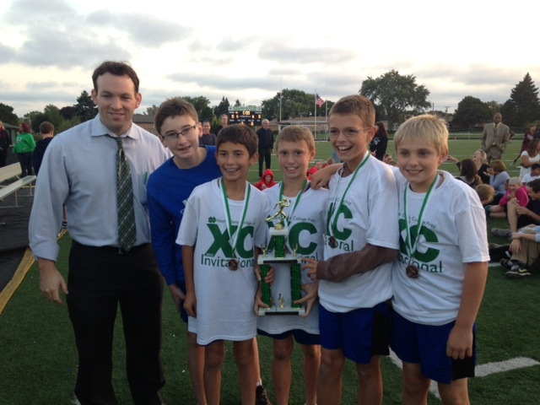 |  | 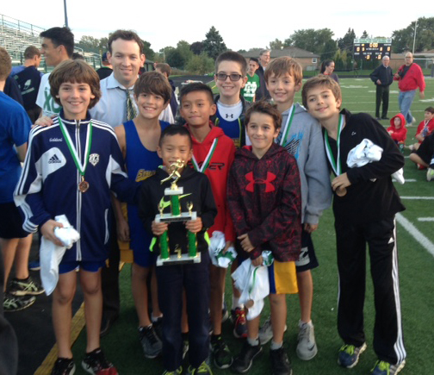 |  | 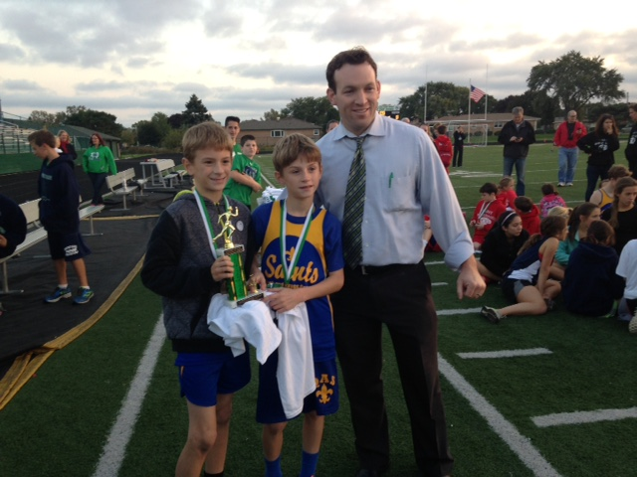
1st Place Junior Varsity Boys  Our Lady of the Wayside |  | 2nd Place Junior Varsity Boys  St. Francis de Sales |  | 3rd Place Junior Varsity Boys  Queen of All Saints

Junior Varsity Boys (5th/6th Grade - 1 mile) - Top 14 Teams
SCHOOL |  |  | SCORE (POINT TOTAL)
Our Lady of the Wayside |  |  | 59
St. Francis de Sales |  |  | 82
Queen of All Saints |  |  | 126
St. Paul of the Cross |  |  | 130
Wildwood |  |  | 189
Edgebrook |  |  | 208
Mary, Seat of Wisdom |  |  | 215
St. Mary of the Woods |  |  | 228
St. Francis Xavier |  |  | 257
St. Athanasius |  |  | 271
Garvy |  |  | 278
CICS |  |  | 382
Peterson |  |  | 463
Palmer |  |  | 521

Junior Varsity Girls (5th/6th Grade - 1 mile) - Top 25 Individuals

NAME |  |  | SCHOOL |  |  | TIME
Mary Grace Hegberg |  |  | Our Lady of the Wayside |  |  | 6:27
Daphne Murray |  |  | OA Thorp |  |  | 6:30
Ryann Grasser |  |  | OA Thorp |  |  | 6:38
Katie Burns |  |  | Onahan |  |  | 6:49
Francesca Spingola |  |  | St. Andrew |  |  | 6:50
Kiera Fitzgerald |  |  | Wildwood |  |  | 6:56
Nadia Arsenijevic |  |  | Edgebrook |  |  | 6:58
Stella Suhar |  |  | St. Andrew |  |  | 7:00
Meghan Twohig |  |  | St. Athanasius |  |  | 7:02
Aliana Carillo |  |  | Smyser |  |  | 7:04
Colleen Kearns |  |  | St. Tarcissus |  |  | 7:05
Maggie Miller |  |  | St. Athanasius |  |  | 7:06
Margaret Jay |  |  | Edgebrook |  |  | 7:07
Isabel Makris |  |  | OA Thorp |  |  | 7:08
Sydney Richards |  |  | St. Andrew |  |  | 7:12
Jen Fisher |  |  | St. Athanasius |  |  | 7:14
Ava Dillon |  |  | St. Paul of the Cross |  |  | 7:16
Lauren Collins |  |  | St. Andrew |  |  | 7:20
Lulu Ward |  |  | St. Athanasius |  |  | 7:21
Holly Feurara |  |  | Mary, Seat of Wisdom |  |  | 7:22
Catherine Quackenbush |  |  | St. Athanasius |  |  | 7:23
Kaylin Fahy |  |  | Onahan |  |  | 7:23
Katherine Arsenijevic |  |  | Wildwood |  |  | 7:23
Jenna Harnson |  |  | St. Athanasius |  |  | 7:23
Lila Mitchell |  |  | St. Andrew |  |  | 7:23

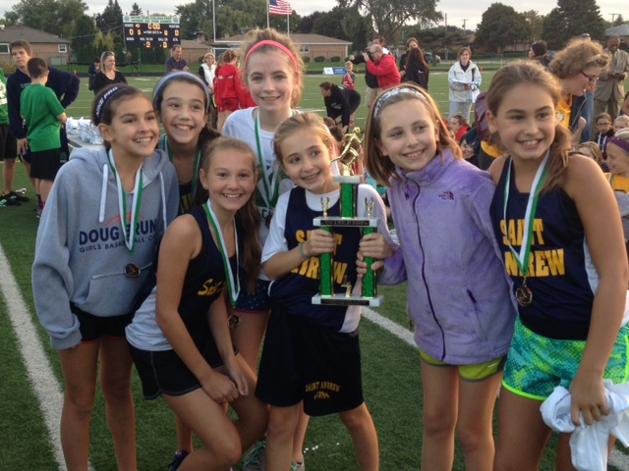 |  | 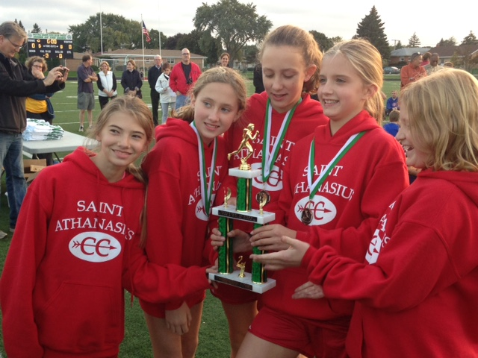 |  | 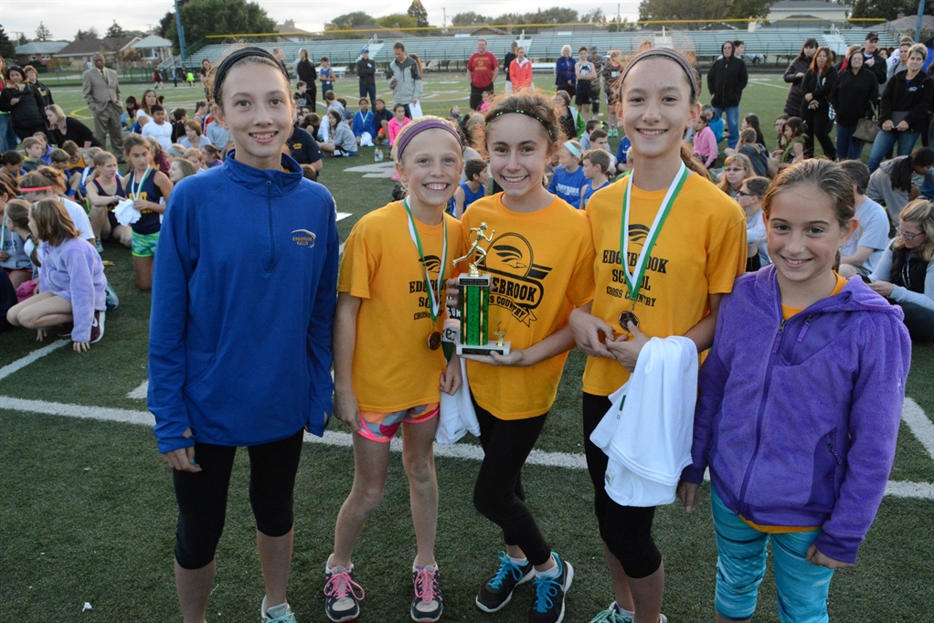
1st Place Junior Varsity Girls  St. Andrew |  | 2nd Place Junior Varsity Girls  St. Athanasius |  | 3rd Place Junior Varsity Girls  Edgebrook  (photo not available)
Junior Varsity Girls (5th/6th Grade - 1 mile) - Top 11 Teams
SCHOOL |  |  | SCORE (POINT TOTAL)
St. Andrew |  |  | 71
St. Athanasius |  |  | 77
Edgebrook |  |  | 134
Onahan |  |  | 141
Queen of All Saints |  |  | 233
St. Mary of the Woods |  |  | 267
CICS |  |  | 338
Smyser |  |  | 366
Dever |  |  | 423
Palmer |  |  | 470
Sauganash |  |  | 486

